STANDARDS & OBJECTIVES: TEKS & VERTICAL ALIGNMENT
TEKS:
Geometry and Measurement
Applying mathematical process standards to solve problems involving angles less than or equal to 180 degrees.
The student is expected to
- Illustrate the measure of an angle as the part of a circle whose center is at the vertex of the angle that is cut out by the rays of the angle. The angle measures are limited to whole numbers.
- Determine the approximate measures of angles in degrees to the nearest whole number using a protractor.
- Determine the measure of an unknown angle formed by two non-overlapping adjacent angles given one or both angle measures.

MATERIALS:
Paper plates
Anglers

QUESTIONS FOR STUDENT THINKING
What do you notice? What do you wonder? Where do you think we should start? What is some information that you already know? How can that information help you with this task? Can you apply another manipulative in solving? How does this make the strategies different? How do they relate?

PROCEDURES:
ACT 1:
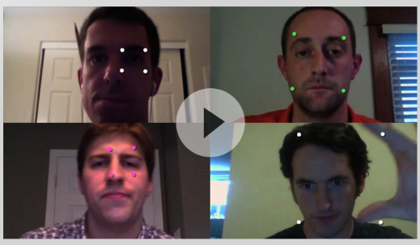
What does the student notice? What do they wonder?
I notice _ the student notices that the squares are different in scale or their sizes vary across all the faces.
I wonder _ the student wonders why the squares are not similar in scale across all the faces.
Allow the students one minute to turn and talk with their elbow partners. I will create a class anchor chart: I notice _
I wonder _
I will record all the student responses on the anchor chart.

ACT 2
Problem to be solved: The student will need to come up with a rule that tells us how any attempt at drawing a square ranks against any other. The attempts may be done using the following resources: sides, areas, angles, and coordinates, and still observe the rule that does not hold up for every case. I will ask them to test their rule against lots of different cases. Their rule has to work using cases that are very large or really small. If they are convinced their rule works, you may want to suggest cases.
Materials: I will provide the students, who are working individually with the video. I will also provide paper plates and anglers to complete the rest of the task.
Student Organization- Each student will work individually on the task for 10 –20 minutes. I will monitor and make decisions based on the outcome available.
Questions for students: How is it possible to draw the best square? What skills do you already have to carry out the task? How can the skills help in carrying out the task? Why? Do you know of another way to carry out this task?
ANTICIPATED RESPONSES: How many squares are needed for this exercise? Can the use of markers and set anglers be helpful in this exercise?
The students could begin by identifying points, line fragments, rays, angles, and parallel and perpendicular lines. They can also indicate whether the lines are perpendicular, and also add symbols for a right angle.
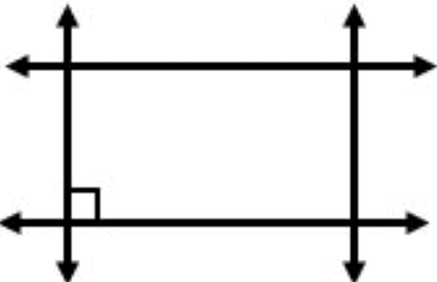

ACT 3: Students will go through the solved example to understand further how it was done (5 minutes). Then each student will take a moment to describe to the class their strategies and how they solved them. I will record on the white board different strategies used. (5 minutes)
How the strategies are different? How are they the same? Can another student explain a different way they can be solved? How can the strategies be recreated?

References: https://mikewiernicki.com/3-act-tasks/
https://gfletchy.com/3-act-lessons/

